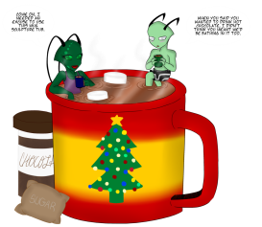HOT CHOCOLATE & MINCE PIES 
FIRST SHOOT OF THE YEAR

At RN SOUTH COAST ARCHERS
Venue: Cams Hill School Shearwater Ave Portchester
1st January 2024 Judge: Paul Richards LadyP/Lord P TBC
Assembly: 11.00 Sighters: 11.15
Round: Indoor Stafford 6 doz @ 30m on a 80cm face, 3 arrows @ foam bosses
Cost £10 Closing date Dec 21st
Name | AGB number | D.O.B | Bow

Club name: ....................................................
payment BACS RN south coast archers 46702490 524132 Ref (your name)
Email entry form to rnsca132@yahoo.co.uk
OR POST TO 20 Goldfinch Lane Lee-on-the-Solent PO13 8LN
Dress code to Archery GB rules 307
If you wish to take photos you need to register at start of competition. When you enter this competition the following information may be collected and shared with tournament organisers,for example target list and results and may be published. Neither RN South Coast archers or Cams Hill School accepts any liability for any injury,damage or loss how so ever caused.

